Monitoring Type: Formal Monitoring

Night Survey #: 1 Outing #: 1 Survey Aborted? N Survey Completed? Y % Survey Area Covered: 30

Sunrise or Sunset Time: 1915

UTMs of New or Intermediate Call Points or Routes (not already mapped):
Call point name | UTME | UTMN |  | Call point name | UTME | UTMN
WEBB3B | 601158 | 3617628
WEBB3C | 601225 | 3617995
Moon phase: 4/4
TIME (24hrs) | Start | End | Total (~ ¼ hr)
Hike-in | 1935 | 1948 | 0.25
Survey | 1948 | 2040 | 1.0
Hike-out | 2040 | 2050 | 0.25
CP or RT # | CM | SM | Time Start | Time End | Total Time | Moon visible? | Wind (mph) | CC % | PPT ? | Temp (◦F) | Obs. Type | Sex | Age | SPP | Time of response | Bearing  (◦) | Distance (m) | UTM E  of owl  (estimated) | UTM N  of owl  (estimated)
WEBB3B | 3 | 2 | 1948 | 2007 | 19 | Y | 0-5 | 10 | 0 | 65 | A | M | U | STOC | 2003 | 93 | 428 | 601590 | 3617607
WEBB3C | 2 | 2 | 2020 | 2038 | 18 | Y | 5-10 | 10 | 0 | 65 | A | M | U | STOC | 2030 | ? | FAR | ---- | ----
CM (Call Method): 1 = tape recording, 2 = vocalization, 3= combination, 4 = owl “hooter”; SM (Survey Method): 1 = leap frog, 2 = point calling, 3=continuous calling; Wind = range in mph; CC= cloud cover, PPT= precipitation (Y or N), Temp = ambient temperature; Obs. Type = aural (A), visual (V) detection, or put (N) for no response. SPP = 4 letter species code based on Latin name; Mex. Spotted Owl = STOC; Great Horned Owl = BUVI; Long-eared Owl = ASOT; Flammulated Owl = OTFL; Whiskered Screech Owl = OTTR; Western Screech Owl = OTKE; Elf Owl = MIWH; Northern Pygmy Owl = GLGN.

Brief Notes:

I hooted periodically while hiking from trailhead to webb3b. No response. Only got reply after 15 mins at webb3b. Sounded far down into canyon. Moved to webb3c to try and get cross bearing, but was so hard to hear male that I couldn’t get reliable bearing. Maybe 162 degrees, but really unsure. I listened for another 8 mins after I heard him from webb3c, but couldn’t get better bearing. Owl is either very far away or behind topographic feature. On the hike back to jeep I paused a few times to listen. Very good conditions for listening, but no more owl heard. It was howling wind on the Goudy canyon side, but on webb peak side was calm. Owl sounded far down into canyon. Maybe Grant Vista male coming over? I don’t think so because last year we heard webb peak male in same area and then got him roosted higher up on slope into Webb Peak PAC.
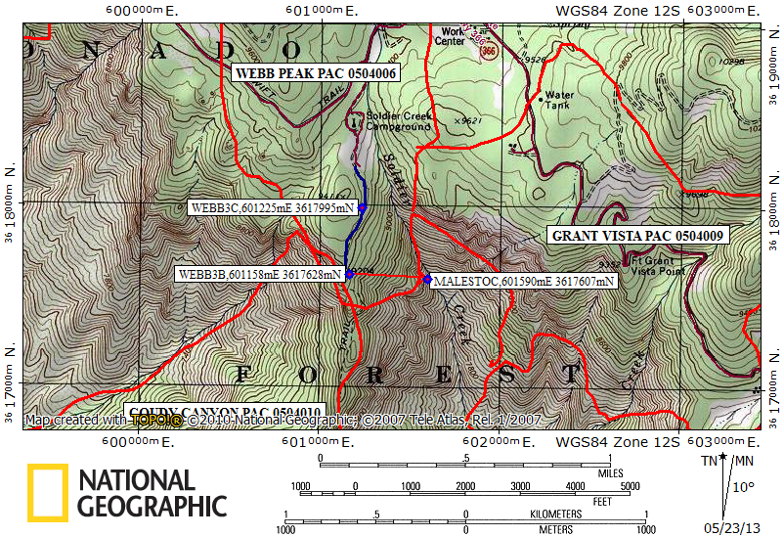
Red line = PAC boundary, blue line = path walked.

